Федеральное государственное бюджетное образовательное учреждение

высшего образования

«Российский экономический университет им. Г.В. Плеханова»

Московский приборостроительный техникум

Специальность: 09.02.07 Информационные системы и программирование

Квалификация: Программист

Общепрофессиональная дисциплина: ОП 08 Основы проектирования баз данных

МПТ.09.02.07-П.ОП.08.ОПБД.П50-5-20.05.22

Отчёт к практической работе № 5

«Реализация таблиц и ограничений в базе данных».

Тема: Разработка базы данных на примере предметной области «Организация наземных

грузоперевозок». Реализация подсистем: учёт автомобильного парка, организация доставки грузов.

|  |  |
| --- | --- |
| Проверил: | Выполнил: |
| Щаников И.М.__________ | Студент группы |
| (________)_____________ | П50-5-20 |
| «___»_____________2022г. | ____________Атаниязов А.А. |
|  | «___»_____________2022г. |

2022

СОДЕРЖАНИЕ

1. ЦЕЛИ ПРАКТИЧЕСКОЙ РАБОТЫ 3

2. ЭТАПЫ ВЫПОЛНЕНИЯ 4

3. ВЫВОД 28

4. СПИСОК ИСПОЛЬЗУЕМОЙ ЛИТЕРАТУРЫ 29

1. ЦЕЛИ ПРАКТИЧЕСКОЙ РАБОТЫ

На основании даталогической модели данных и словаря данных, разработать структуру таблиц базы данных, на сервере СУБД.

2. ЭТАПЫ ВЫПОЛНЕНИЯ

1) Проект даталогической модели данных, на основании 4 практической работы:

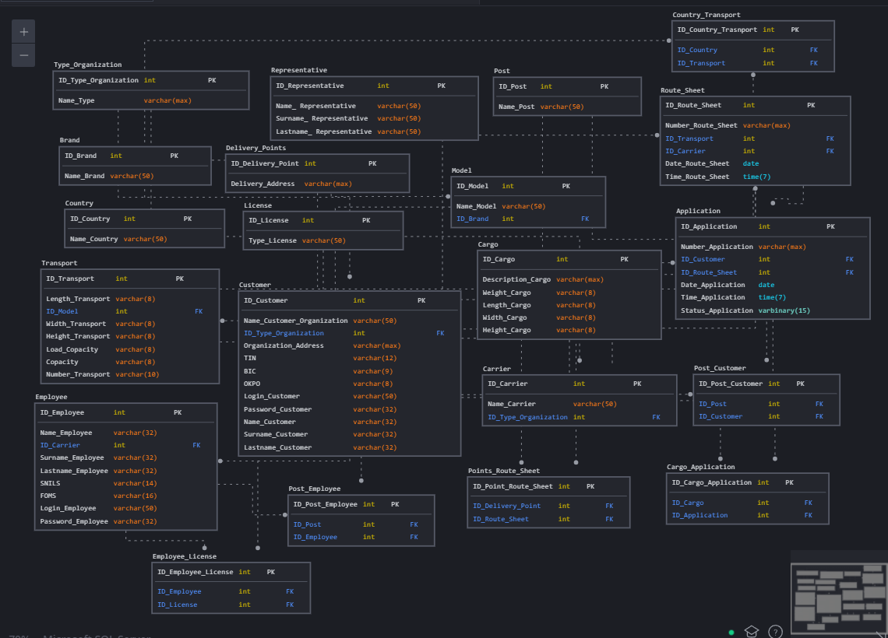

2) Реализация скрипта настройки и создания файла базы данных:

|  |  |
| --- | --- |
| Название объекта | Скрипт объекта |
| Test_Cargo1 | set ansi_nulls on  go  set ansi_padding on  go  set quoted_identifier on  go  create database [Test_Cargo1]  go  use [Test_Cargo1]  go |

3) На основании словаря данных, произвести реализацию родительских таблиц базы данных (Поле с типом данных, Varchar (max), не может быть с ограничением unique – пометить желтым цветом):

|  |  |  |  |  |
| --- | --- | --- | --- | --- |
| Ключ | Наименование | Тип данных | Примечание | Скрипт объекта |
| Representative | | | | |
| PK | ID_Representative | INT | Первичный ключ таблицы «Представитель» | create table [dbo].[Representative]  (  [ID_Representative] [int] not null identity(1,1),  [Name_ Representative] [varchar] (50) not null,  [Surname_ Representative] [varchar] (50) not null,  [Lastname_ Representative] [varchar] (50) not null,  constraint [PK_Representative] primary key clustered  ([ID_Representative] ASC) on [PRIMARY]  )  go |
|  | Name_ Representative | VARCHAR(50) |  |
|  | Surname_ Representative | VARCHAR(50) |  |
|  | Lastname_ Representative | VARCHAR(50) |  |
| Post | | | | |
| PK | ID_Post | INT | Первичный ключ таблицы «Должность» | create table [dbo].[Post]  (  [ID_Post] [int] not null identity(1,1),  [Name_Post] [varchar] (50) not null  constraint [PK_Post] primary key clustered  ([ID_Post] ASC) on [PRIMARY],  constraint [UQ_Name_Post] unique ([Name_Post])  )  go |
|  | Name_Post | VARCHAR(50) | Уникальное поле |
| Delivery_Points | | | | |
| PK | ID_Delivery_Points | INT | Первичный ключ таблицы «Точки доставки» | create table [dbo].[Delivery_Points]  (  [ID_Delivery_Point] [int] not null identity(1,1),  [Delivery_Address] [varchar] (max) not null  constraint [PK_Delivery_Point] primary key clustered  ([ID_Delivery_Point] ASC) on [PRIMARY]  )  go |
|  | Delivery_Addres | VARCHAR(50) | Уникальное поле |
| Brand | | | | |
| PK | ID_Brand | INT | Первичный ключ таблицы «Марка» | create table [dbo].[Brand]  (  [ID_Brand] [int] not null identity(1,1),  [Name_Brand] [varchar] (50) not null  constraint [PK_Brand] primary key clustered  ([ID_Brand] ASC) on [PRIMARY],  constraint [UQ_Name_Brand] unique ([Name_Brand])  )  go |
|  | Name_Brand | VARCHAR(50) | Уникальное поле |
| Type_Organization | | | | |
| PK | ID_Type_Organization | INT | Первичный ключ таблицы «Тип организации» | create table [dbo].[Type_Organization]  (  [ID_Type_Organization] [int] not null identity(1,1),  [Type_Name] [varchar] (max) not null  constraint [PK_Type_Organization] primary key clustered  ([ID_Type_Organization] ASC) on [PRIMARY]  )  go |
|  | Name_Type | VARCHAR(50) | Уникальное поле |
| License | | | | |
| PK | ID_License | INT | Первичный ключ таблицы «Права» | create table [dbo].[License]  (  [ID_License] [int] not null identity(1,1),  [Type_License] [varchar] (10) not null  constraint [PK_License] primary key clustered  ([ID_License] ASC) on [PRIMARY],  constraint [UQ_Type_License] unique ([Type_License])  )  go |
|  | Type_License | VARCHAR(10) | Уникальное поле |
| Cargo | | | | |
| PK | ID_Cargo | INT | Первичный ключ таблицы «Груз» | create table [dbo].[Cargo]  (  [ID_Cargo] [int] not null identity(1,1),  [Description_Cargo] [varchar] (max) not null,  [Weight_Cargo] [varchar] (8) not null,  [Length_Cargo] [varchar] (8) not null,  [Width_Cargo] [varchar] (8) not null,  [Height_Cargo] [varchar] (8) not null  constraint [PK_Cargo] primary key clustered  ([ID_Cargo] ASC) on [PRIMARY],  constraint [CH_Weight_Cargo] check ([Weight_Cargo] like ('[0-9][0-9][0-9]')  or [Weight_Cargo] like ('[0-9][0-9][0-9][0-9]') or [Weight_Cargo] like ('[0-9][0-9][0-9][0-9][0-9]')),  constraint [CH_Length_Cargo] check ([Length_Cargo] like ('[0-9][0-9][0-9]')  or [Length_Cargo] like ('[0-9][0-9][0-9][0-9]') or [Length_Cargo] like ('[0-9][0-9][0-9][0-9][0-9]')),  constraint [CH_Width_Cargo] check ([Width_Cargo] like ('[0-9][0-9][0-9]')  or [Width_Cargo] like ('[0-9][0-9][0-9][0-9]') or [Width_Cargo] like ('[0-9][0-9][0-9][0-9][0-9]')),  constraint [CH_Height_Cargo] check ([Height_Cargo] like ('[0-9][0-9][0-9]')  or [Height_Cargo] like ('[0-9][0-9][0-9][0-9]') or [Height_Cargo] like ('[0-9][0-9][0-9][0-9][0-9]'))  )  go |
|  | Description_Cargo | VARCHAR(MAX) |  |
|  | Weight_Cargo | VARCHAR(8) |  |
|  | Length_Cargo | VARCHAR(8) |  |
|  | Width_Cargo | VARCHAR(8) |  |
|  | Height_Cargo | VARCHAR(8) |  |
| Country | | | | |

|  |  |  |  |
| --- | --- | --- | --- |
| ID_Country | INT | Первичный ключ таблицы «Страна» | create table [dbo].[Country]  (  [ID_Country] [int] not null identity(1,1),  [Name_Country] [varchar] (50) not null  constraint [PK_Country] primary key clustered  ([ID_Country] ASC) on [PRIMARY],  constraint [UQ_Name_Country] unique ([Name_Country])  )  go |
| Name_Country | VARCHAR(50) | Уникальное поле |

4) На основании словаря данных, произвести реализацию дочерних таблиц с одной связью 1:М:

|  |  |  |  |  |
| --- | --- | --- | --- | --- |
| Ключ | Наименование | Тип данных | Примечание | Скрипт объекта |
| Carrier | | | | |
| PK | ID_Carrier | INT | Первичный ключ таблицы «Перевозчик» | create table [dbo].[Carrier]  (  [ID_Carrier] [int] not null identity(1,1),  [Name_Carrier] [varchar] (50) not null,  [Type_Organization_ID] [int] not null  constraint [PK_Carrier] primary key clustered  ([ID_Carrier] ASC) on [PRIMARY],  constraint [UQ_Name_Carrier] unique ([Name_Carrier]),  constraint [FK_Type_Organization_Carrier] foreign key ([Type_Organization_ID])  references [dbo].[Type_Organization] ([ID_Type_Organization])  )  go |
|  | Name_Carrier | VARCHAR(50) | Уникальное поле |
| FK | Type_Organization_ID | INT |  |
| Transport | | | | |
| PK | ID_Transport | INT | Первичный ключ таблицы «Транспорт» | create table [dbo].[Transport]  (  [ID_Transport] [int] not null identity(1,1),  [Length_Transport] [varchar] (8) not null,  [Width_Transport] [varchar] (8) not null,  [Height_Transport] [varchar] (8) not null,  [Load_Copacity] [varchar] (8) not null,  [Copacity] [varchar] (9) not null,  [Number_Transport] [varchar] (10) not null,  [Model_ID] [int] not null  constraint [PK_Transport] primary key clustered  ([ID_Transport] ASC) on [PRIMARY],  constraint [CH_Length_Transport] check ([Length_Transport] like ('[0-9][0-9][0-9][0-9]')),  constraint [CH_Width_Transport] check ([Width_Transport] like ('[0-9][0-9][0-9][0-9]')),  constraint [CH_Height_Transport] check ([Height_Transport] like ('[0-9][0-9][0-9][0-9]')),  constraint [CH_Load_Copacity] check ([Load_Copacity] like ('[0-9][0-9][0-9][0-9]')  or [Load_Copacity] like ('[0-9][0-9][0-9][0-9][0-9]')),  constraint [CH_Copacity] check ([Copacity] like ('[0-9][0-9]')),  constraint [CH_Number_Transport] check ([Number_Transport] like ('[А-Я][0-9][0-9][0-9][А-Я][А-Я]')),  constraint [UQ_Number_Transport] unique ([Number_Transport]),  constraint [FK_Model_Transport] foreign key ([Model_ID])  references [dbo].[Model] ([ID_Model])  )  go |
|  | Length_Transport | VARCHAR(8) | «0000 мм» |
|  | Width_Transport | VARCHAR(8) | «0000 мм» |
|  | Height_Transport | VARCHAR(8) | «0000 мм» |
|  | Load_Copacity | VARCHAR(8) | «00009 кг» |
|  | Copacity | VARCHAR(9) | «00 куб. м» |
|  | Number_Transport | VARCHAR(10) | «[А-Я]000[А-Я][А-Я]-009», уникальное поле |
| FK | Model_ID | INT |  |
| Employee | | | | |
| PK | ID_Employee | INT | Первичный ключ таблицы «Сотрудник» | create table [dbo].[Employee]  (  [ID_Employee] [int] not null identity(1,1),  [Name_Employee] [varchar] (32) not null,  [Surname_Employee] [varchar] (32) not null,  [Lastname_Employee] [varchar] (32) null default('-'),  [SNILS] [varchar] (14) not null,  [FOMS] [varchar] (16) not null,  [Login_Employee] [varchar] (50) not null,  [Password_Employee] [varchar] (32) not null,  [Carrier_ID] [int] not null  constraint [PK_Employee] primary key clustered  ([ID_Employee] ASC) on [PRIMARY],  constraint [UQ_SNILS] unique ([SNILS]),  constraint [CH_SNILS] check  ([SNILS] like ('[0-9][0-9][0-9]-[0-9][0-9][0-9]-[0-9][0-9][0-9] [0-9][0-9]')),  constraint [UQ_FOMS] unique ([FOMS]),  constraint [CH_FOMS] check  ([FOMS] like ('[0-9][0-9][0-9][0-9][0-9][0-9][0-9][0-9][0-9][0-9][0-9][0-9][0-9][0-9][0-9][0-9]')),  constraint [UQ_Login_Employee] unique ([Login_Employee]),  constraint [CH_Login_Employee] check (len([Login_Employee])>=8),  constraint [CH_Password_Employee] check  (len([Password_Employee]) >=4),  constraint [FK_Carrier_Employee] foreign key ([Carrier_ID])  references [dbo].[Carrier] ([ID_Carrier])  )  go |
|  | Name_Employee | VARCHAR(32) |  |
|  | Surname_Employee | VARCHAR(32) |  |
|  | Lastname_Employee | VARCHAR(32) |  |
|  | SNILS | VARCHAR(14) | «000-000-000 00», уникальное поле |
|  | FOMS | VARCHAR(16) | 0000000000000000, уникальное поле |
|  | Login_Employee | VARCHAR(50) | Не менее 8 символов, уникальное поле |
|  | Password_Employee | VARCHAR(32) | Спец. символы, минимум одна прописная или заглавная латинская буква |
| FK | Carrier_ID | INT |  |
| Model | | | | |
| PK | ID_Model | INT | Первичный ключ таблицы «Модель» | create table [dbo].[Model]  (  [ID_Model] [int] not null identity(1,1),  [Name_Model] [varchar] (50) not null,  [Brand_ID] [int] not null  constraint [PK_Model] primary key clustered  ([ID_Model] ASC) on [PRIMARY],  constraint [UQ_Name_Model] unique ([Name_Model]),  constraint [FK_Brand_Model] foreign key ([Brand_ID])  references [dbo].[Brand] ([ID_Brand])  )  go |
|  | Name_Model | VARCHAR(50) | Уникальное поле |
| FK | Brand_ID | INT |  |
| Customer | | | | |
| PK | ID_Customer | INT | Первичный ключ таблицы «Заказчик» | create table [dbo].[Customer]  (  [ID_Customer] [int] not null identity(1,1),  [Name_Customer_Organization] [varchar] (50) not null,  [Organization_Address] [varchar] (max) not null,  [TIN] [varchar] (12) not null,  [BIC] [varchar] (9) not null,  [OKPO] [varchar] (8) not null,  [Login_Customer] [varchar] (50) not null,  [Password_Customer] [varchar] (32) not null,  [Name_Customer] [varchar] (32) not null,  [Surname_Customer] [varchar] (32) not null,  [Lastname_Customer] [varchar] (32) null default('-'),  [Type_Organization_ID] [int] not null,  [Representative_ID] [int] not null  constraint [PK_Customer] primary key clustered  ([ID_Customer] ASC) on [PRIMARY],  constraint [CH_TIN] check  ([TIN] like ('[0-9][0-9][0-9][0-9][0-9][0-9][0-9][0-9][0-9][0-9][0-9][0-9]')),  constraint [UQ_TIN] unique ([TIN]),  constraint [CH_BIC] check ([BIC] like ('[0-9][0-9][0-9][0-9][0-9][0-9][0-9][0-9][0-9]')),  constraint [CH_OKPO] check ([OKPO] like ('[0-9][0-9][0-9][0-9][0-9][0-9][0-9][0-9]')),  constraint [UQ_OKPO] unique ([OKPO]),  constraint [CH_Login_Customer] check  (len([Login_Customer]) >=8),  constraint [UQ_Login_Customer] unique ([Login_Customer]),  constraint [CH_Password_Customer] check  (len([Password_Customer]) >=4),  constraint [FK_Type_Organization_Customer] foreign key ([Type_Organization_ID])  references [dbo].[Type_Organization] ([ID_Type_Organization]),  constraint [FK_Representative_Customer] foreign key ([Representative_ID])  references [dbo].[Representative] ([ID_Representative])  )  go |
|  | Name_Customer_Organiztion | VARCHAR(50) |  |
|  | Organiztion_Address | VARCHAR(MAX) |  |
|  | TIN | VARCHAR(12) | 000000000000, уникальное поле |
|  | BIC | VARCHAR(9) | 000000000 |
|  | OKPO | VARCHAR(8) | 00000000 |
|  | Login_Customer | VARCHAR(50) | Не менее 8 символов, уникальное поле |
|  | Password_Customer | VARCHAR(32) | Спец. символы, минимум одна прописная или заглавная латинская буква |
|  | Name_Customer | VARCHAR(32) |  |
|  | Surname_Customer | VARCHAR(32) |  |  |
|  | Lastname_Customer | VARCHAR(32) |  |  |
|  | Type_Organization_ID | INT |  |  |
| FK | ID_Customer | INT | Первичный ключ таблицы «Заказчик» |  |

5) На основании словаря данных, произвести реализацию, дочерних таблиц со связями М:М:

|  |  |  |  |  |
| --- | --- | --- | --- | --- |
| Ключ | Наименование | Тип данных | Примечание | Скрипт объекта |
| Country_Transport | | | | |
| PK | ID_Country_Transport | INT | Первичный ключ таблицы «Страна транспорта» | create table [dbo].[Country_Trasnport]  (  [ID_Country_Transport] [int] not null identity(1,1),  [Country_ID] [int] not null,  [Transport_ID] [int] not null  constraint [PK_Country_Transport] primary key clustered  ([ID_Country_Transport] ASC) on [PRIMARY],  constraint [FK_Country] foreign key ([Country_ID])  references [dbo].[Country] ([ID_Country]),  constraint [FK_Transport] foreign key ([Transport_ID])  references [dbo].[Transport] ([ID_Transport]),  )  go |
| FK | Country_ID | INT |  |
| FK | Transport_ID | INT |  |
| Application | | | | |
| PK | ID_Application | INT | Первичный ключ таблицы заявка | create table [dbo].[Application]  (  [ID_Application] [int] not null identity(1,1),  [Number_Application] [varchar] (max) not null,  [Date_Time_Application] [datetime] not null default(getdate()),  [Customer_ID] [int] not null,  [Route_Sheet_ID] [int] not null,  [Status_Application] [varchar] (15) not null  constraint [PK_Application] primary key clustered  ([ID_Application] ASC) on [PRIMARY],  constraint [CH_Number_Application] check  ([Number_Application] like ('[0-9][0-9][0-9][0-9]-[0-9][0-9]')),  constraint [CH_Status_Application] check  ([Status_Application] in ('Обработан', 'Обрабатывается', 'Отменен')),  constraint [FK_Customer_Application] foreign key ([Customer_ID])  references [dbo].[Customer] ([ID_Customer]),  constraint [FK_Customer_Route_Sheet] foreign key ([Route_Sheet_ID])  references [dbo].[Route_Sheet] ([ID_Route_Sheet]),  )  go |
|  | Number_Application | VARCHAR(MAX) | 0000-00, уникальное поле |
|  | Date_Application | DATE | Текущая дата |
|  | Time_Application | TIME | Текущее время |
|  | Status_Application | VARCHAR(15) | «Доставлен», «Доставляется», «Отменен» |
| FK | Customer_ID | INT |  |
| FK | Route_Sheet_ID | INT |  |
| Points_Route_Sheet | | | | |
| PK | ID_Point_Route_Sheet | INT | Первичный ключ таблицы «Точки маршрутного листа» | create table [dbo].[Points_Route_Sheet]  (  [ID_Point_Route_Sheet] [int] not null identity(1,1),  [Delivery_Point_ID] [int] not null,  [Route_Sheet_ID] [int] not null  constraint [PK_Point_Route_Sheet] primary key clustered  ([ID_Point_Route_Sheet] ASC) on [PRIMARY],  constraint [FK_Delivery_Point] foreign key ([Delivery_Point_ID])  references [dbo].[Delivery_Points] ([ID_Delivery_Point]),  constraint [FK_Route_Sheet] foreign key ([Route_Sheet_ID])  references [dbo].[Route_Sheet] ([ID_Route_Sheet]),  )  go |
| FK | Delivery_Point_ID | INT |  |
| FK | Route_Sheet_ID | INT |  |
| Post_Customer | | | | |
| PK | ID_Post_Customer | INT | Первичный ключ таблицы «Должность заказчика» | create table [dbo].[Post_Customer]  (  [ID_Post_Customer] [int] not null identity(1,1),  [Post_ID] [int] not null,  [Customer_ID] [int] not null  constraint [PK_Post_Customer] primary key clustered  ([ID_Post_Customer] ASC) on [PRIMARY],  constraint [FK_Post] foreign key ([Post_ID])  references [dbo].[Post] ([ID_Post]),  constraint [FK_Customer] foreign key ([Customer_ID])  references [dbo].[Customer] ([ID_Customer]),  )  go |
| FK | Post_ID | INT |  |
| FK | Customer_ID | INT |  |
| Route_Sheet | | | | |
| PK | ID_Route_Sheet | INT | Первичный ключ таблицы «Маршрутный лист» | create table [dbo].[Route_Sheet]  (  [ID_Route_Sheet] [int] not null identity(1,1),  [Number_Route_Sheet] [varchar] (max) not null,  [Date_Route_Sheet] [date] not null default(getdate()),  [Time_Route_Sheet] [time] not null default(getdate()),  [Carrier_ID] [int] not null,  [Transport_ID] [int] not null  constraint [PK_Route_Sheet] primary key clustered  ([ID_Route_Sheet] ASC) on [PRIMARY],  constraint [CH_Number_Route_Sheet] check  ([Number_Route_Sheet] like ('[0-9][0-9][0-9][0-9]-[0-9][0-9]')),  constraint [FK_Carrier_Route_Sheet] foreign key ([Carrier_ID])  references [dbo].[Carrier] ([ID_Carrier]),  constraint [FK_Transport_Route_Sheet] foreign key ([Transport_ID])  references [dbo].[Transport] ([ID_Transport]),  )  go |
|  | Number_Route_Sheet | VARCHAR(MAX) | 0000-00, уникальное поле |
|  | Date_Route_Sheet | DATE | Текущая дата |
|  | Time_Route_Sheet | TIME | Текущее время |  |
| FK | Carrier_ID | INT |  |  |
| FK | Transport_ID | INT |  |  |
| Post_Employee | | | | |
| PK | ID_Post_Employee | INT | Первичный ключ таблицы «Должность сотрудника» | create table [dbo].[Post_Employee]  (  [ID_Post_Employee] [int] not null identity(1,1),  [Post_ID] [int] not null,  [Employee_ID] [int] not null  constraint [PK_Post_Employee] primary key clustered  ([ID_Post_Employee] ASC) on [PRIMARY],  constraint [FK_Post_Employee] foreign key ([Post_ID])  references [dbo].[Post] ([ID_Post]),  constraint [FK_Employee] foreign key ([Employee_ID])  references [dbo].[Employee] ([ID_Employee]),  )  go |
| FK | Post_ID | INT |  |
| FK | Employee_ID | INT |  |
| Cargo_Application | | | | |
| PK | ID_Cargo_Applocation | INT | Первичный ключ таблицы «Заявка груза» | create table [dbo].[Cargo_Application]  (  [ID_Cargo_Application] [int] not null identity(1,1),  [Cargo_ID] [int] not null,  [Application_ID] [int] null  constraint [PK_Cargo_Application] primary key clustered  ([ID_Cargo_Application] ASC) on [PRIMARY],  constraint [FK_Cargo] foreign key ([Cargo_ID])  references [dbo].[Cargo] ([ID_Cargo]),  constraint [FK_Application] foreign key ([Application_ID])  references [dbo].[Application] ([ID_Application])  )  go |
| FK | Cargo_ID | INT |  |
| FK | Application_ID | INT |  |
| Employee_License | | | | |
| PK | ID_Employee_License | INT | Первичный ключ таблицы «Права сотрудника» | create table [dbo].[Employee_License]  (  [ID_Employee_License] [int] not null identity(1,1),  [Employee_ID] [int] not null,  [License_ID] [int] null  constraint [PK_Employee_License] primary key clustered  ([ID_Employee_License] ASC) on [PRIMARY],  constraint [FK_Employee_License] foreign key ([Employee_ID])  references [dbo].[Employee] ([ID_Employee]),  constraint [FK_License] foreign key ([License_ID])  references [dbo].[License] ([ID_License])  )  go |
| FK | Employee_ID | INT |  |
| FK | License_ID | INT |  |

6) Продемонстрировать результат разработанной базы данных, приложив иллюстрации обозревателя объектов, среды разработки базы данныъ:

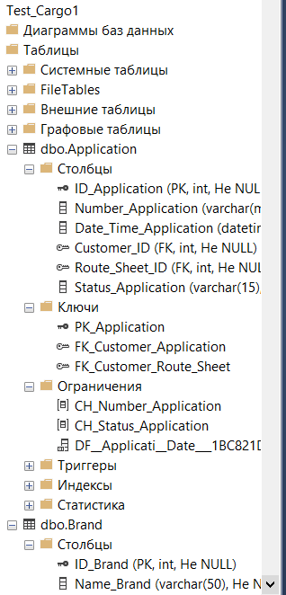

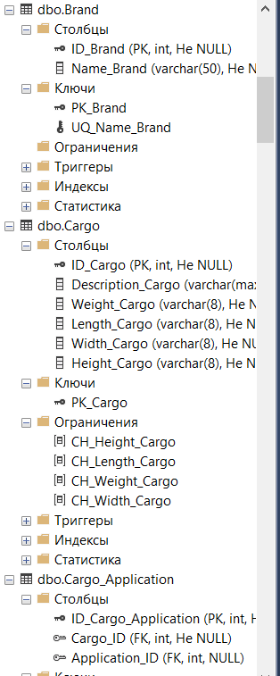

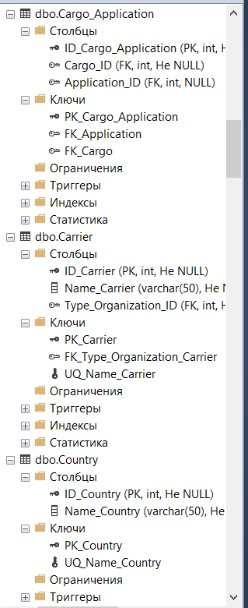

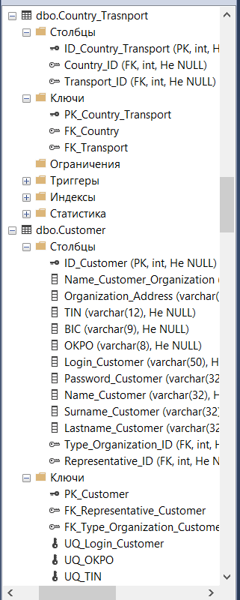

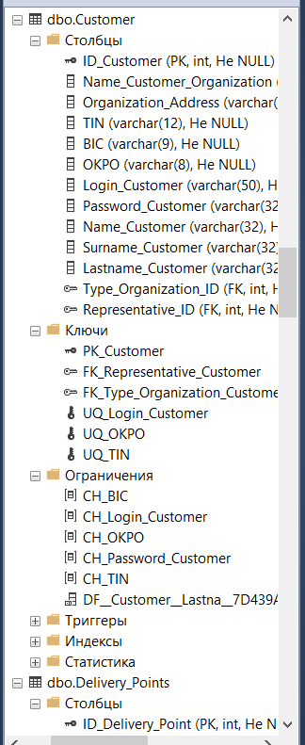

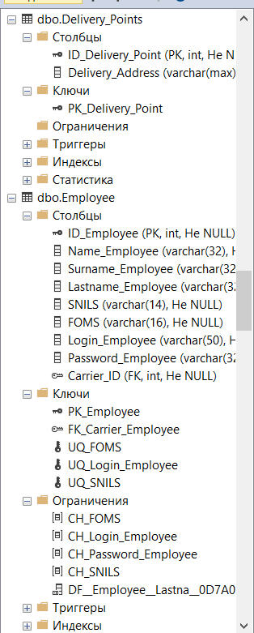

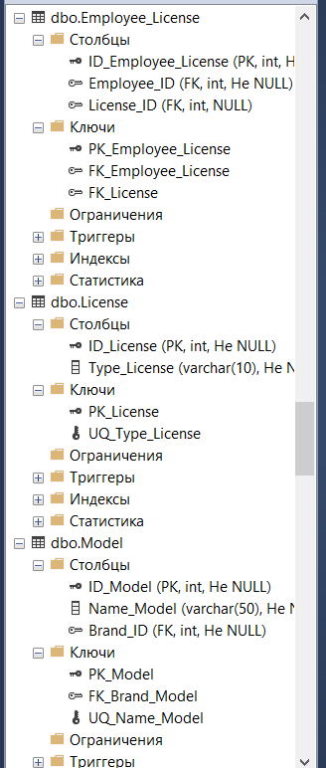

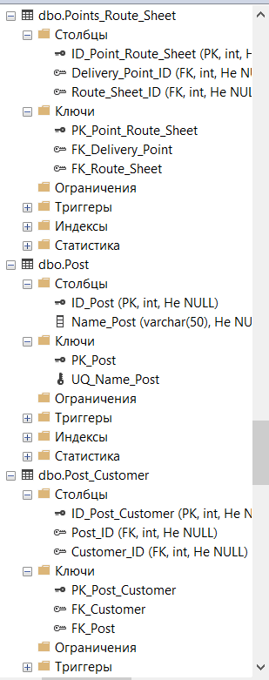

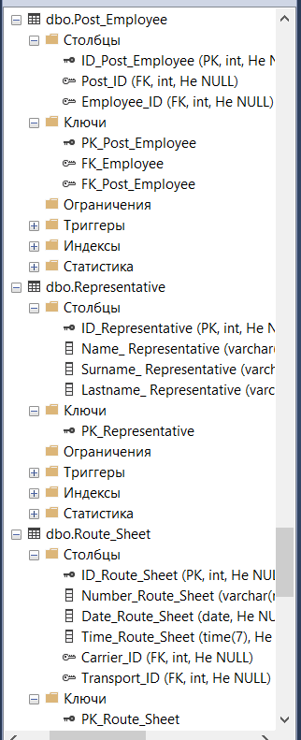

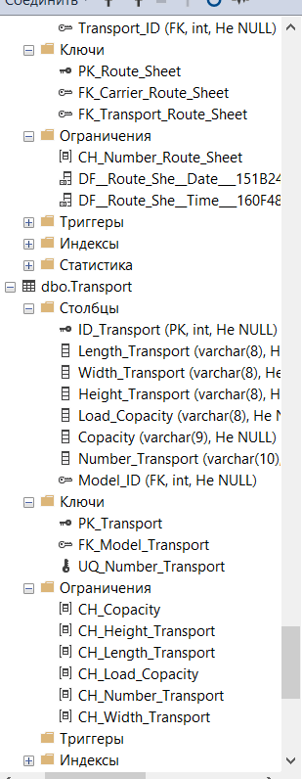

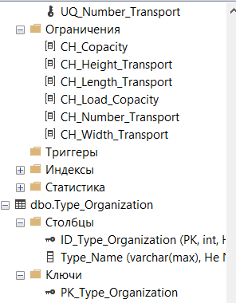

7) Продемонстрировать даталогическую модель данных, из инструментальной среды разработки баз данных:

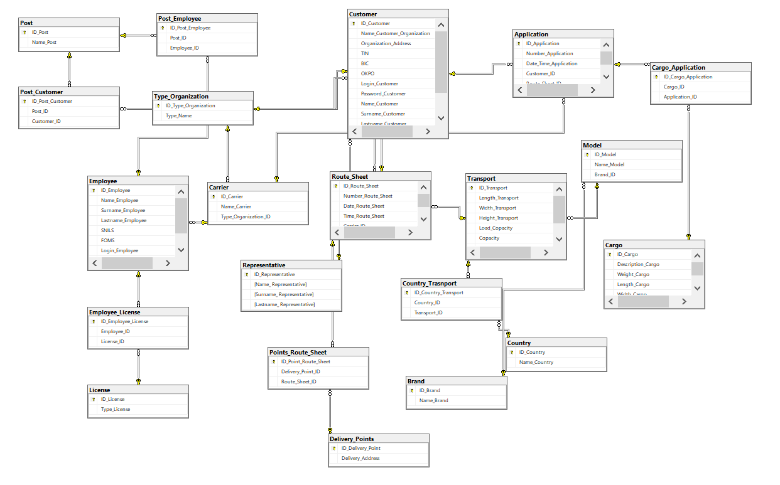

3. ВЫВОД

В ходе практической работы были получены навыки создания базы данных на основании даталогических данных и словаря данных.

4. СПИСОК ИСПОЛЬЗУЕМОЙ ЛИТЕРАТУРЫ

1. Теоретические сведения к выполнению практической работы.